PEMS PICKLEBALL TOURNAMENT
********************************************************************************************************
Friday, March 13th
5:30- 8:00
Pittsville School Gym

We’d like to invite you to participate in our first annual Pickleball Tournament! Pickleball has become a popular sport at Pittsville and we’d like to share the fun with the families of our students, as well! Participation in the Pickleball Tournament is open to all Pittsville Elementary and Middle School students & families. You don’t have to be “good” at the sport to have a great time! (Game rules are on the back.) First time players are welcome and encouraged to join. We have equipment you may use- we just ask that you wear athletic shoes for your safety as you play the game!
Each team will consist of 2 players. There must be at least one Pittsville Student/Employee on each team. Other members may be family members, friends, etc!
Registration Fee for each team is $30. Included in this registration fee:
- Each Player will receive a long sleeve athletic Pittsville Pickleball Shirt
- Each team will play in multiple games
- Each team will be in the running for a championship trophy
Open Gym Time (To practice Pickleball or to give it a try!)
- Wednesday 2/12 5:30- 7:00 (During PTA Night)
- Thursday 2/20 4:00- 5:00

Registration for the tournament is due by Thursday, February 27th. Please submit the form to Mrs. McCauley, Mr. Clouser, or Ms. Gray.
All are welcome to attend the event! There will be a $5 admission fee at the door, if not playing in the tournament. Food and drinks will be available for purchase. This tournament is a PE fundraiser which benefits the Athletic Department & Athletic Teams. Shirts will be available for purchase at the event, as well! The cost is $20. Please see our website for the color version of the shirt!
Please contact Mrs. McCauley or Mr. Clouser with questions.
lmccaule@wcboe.org jclouser@wcboe.org
We are looking forward to a fun night!
Go Wildcats!
~ Mrs. McCauley, Mr. Clouser & Ms. Gray

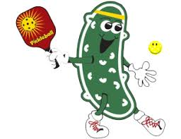
RULES of PICKLEBALL
- Rock, paper, and scissors will determine the first serve
- On the first serve of the game, the person on the right side of the court serves first and continues to serve (alternating sides with partner) until the team loses the point. Then, the serve goes to the opposite team, to the person on the right side of the court. That person will serve until that person’s team loses the point. Then, the serve goes to that persons teammate. For the rest of the game, it follows in that fashion. Both players on the team will serve, alternating sides every time a point is scored, before it goes back to the other team. The person on the right side of the court is always the first to serve.
- A player is not permitted to volley any shot from between the net and 7' non-volley zone line (called the kitchen) or to step into this area as part of a volley follow-through.
- Volley means to hit the ball BEFORE it bounces
- We will begin play with a serve
  - The serve must be cross-court & behind non-volley zone (kitchen)
  - Must be an underhand serve
  - The ball MUST bounce before returned by the other team
  - Server must be behind baseline and foot must not touch the baseline
- Double Bounce Rule is in effect - each team must play its first shot off the bounce
(this includes the serve and first return of serve)

- Rally Scoring- Every time your opponent faults your team gets the point
- The following are Faults
  - fails to return ball
  - hits ball out of bounds
  - hits ball so that it does not clear the net
  - volleying the ball before it has bounced on each side of the net
- If the ball hits the side basketball hoops, replay the point
- The winner will be determined by whoever is ahead after a predetermined amount of time. It is recommended the server announce the score before each serve
- A ball bouncing on any of the boundary lines is considered “in-play”
- Most importantly, good sportmanship will be expected and lack thereof will result in immediate dismissal from the tournament
- Refunds can not be issued
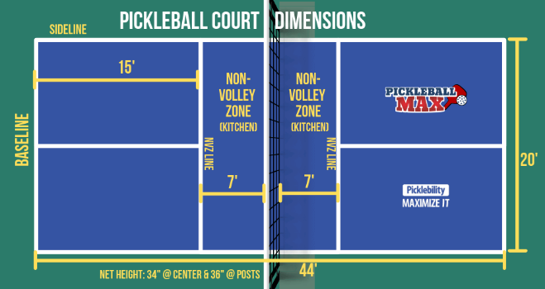

*PITTSVILLE PICKLEBALL TOURNAMENT REGISTRATION FORM*
*ONE Registration Form Per Team
*Payment of $30 per Team
*Please return this form with the registration fee by February 27th

Player #1 Name:_______________________________ Phone #:__________________________
Circle Shirt Size: Child Small/ Child Medium/ Child Large/ Adult Small/ Adult Medium/ Adult Large/ Adult X-Large/ Adult 2X / Adult 3X
*Please make checks payable to Pittsville School
*Submit form to Mrs. McCauley or Mr. Clouser

For Adults At Least 18 Years and Older

I understand and agree that I am voluntarily participating in the PEMS Pickleball Tournament on March 13, 2020. I understand and acknowledge that any physical activity has inherent risk and that I fully accept responsibility for participating. I certify that I have no physical, medical or any other known condition or restriction that would prevent me from actively participating. I understand that pickleball is a potentially hazardous physical activity and that I should not enter the PEMS Pickleball Tournament on March 13th unless I am medically able and properly trained. I hereby acknowledge by signing this form that I am participating in PEMS Pickleball Tournament on March 13, 2020 at my own risk.

Print Name: _____________________________ Association with PEMS:_________________________

Signature: ______________________________ Date: _________________

Disclosure and Permission

For Children Under the Age of 18 (To Be Signed by Parent or Guardian)
I am the parent or guardian of the child named below. I understand and agree that they are voluntarily participating in the PEMS Pickleball Tournament on March 13, 2020. I understand and acknowledge that any physical activity has inherent risk and that I fully accept responsibility for their participation. I certify that they have no physical, medical or any other known condition or restriction that would prevent them from actively participating. I understand that pickleball is a potentially hazardous physical activity and that they should not enter the PEMS Pickleball Tournament on March 13, 2020 unless they are medically able and properly trained. I hereby acknowledge by signing this form that my child(ren) will be participating in the PEMS Pickleball Tournament on March 13, 2020 at their own risk.

Print Child’s Name: __________________________________________

Signature of Parent or Guardian: _______________________________ Date: ____________

Player #2 Name:_________________________ Phone #:__________________
Circle Shirt Size: Child Small/ Child Medium/ Child Large/ Adult Small/ Adult Medium/ Adult Large/ Adult X-Large/ Adult 2X / Adult 3X

For Adults At Least 18 Years and Older
I understand and agree that I am voluntarily participating in the PEMS Pickleball Tournament on March 13, 2020. I understand and acknowledge that any physical activity has inherent risk and that I fully accept responsibility for participating. I certify that I have no physical, medical or any other known condition or restriction that would prevent me from actively participating. I understand that pickleball is a potentially hazardous physical activity and that I should not enter the PEMS Pickleball Tournament on March 13th unless I am medically able and properly trained. I hereby acknowledge by signing this form that I am participating in PEMS Pickleball Tournament on March 13, 2020 at my own risk.

Print Name: _____________________________ Association with PEMS:_________________________

Signature: ______________________________ Date: _________________

Disclosure and Permission
For Children Under the Age of 18 (To Be Signed by Parent or Guardian)
I am the parent or guardian of the child named below. I understand and agree that they are voluntarily participating in the PEMS Pickleball Tournament on March 13, 2020. I understand and acknowledge that any physical activity has inherent risk and that I fully accept responsibility for their participation. I certify that they have no physical, medical or any other known condition or restriction that would prevent them from actively participating. I understand that pickleball is a potentially hazardous physical activity and that they should not enter the PEMS Pickleball Tournament on March 13, 2020 unless they are medically able and properly trained. I hereby acknowledge by signing this form that my child(ren) will be participating in the PEMS Pickleball Tournament on March 13, 2020 at their own risk.

Print Child’s Name: __________________________________________

Signature of Parent or Guardian: _______________________________ Date: ____________

